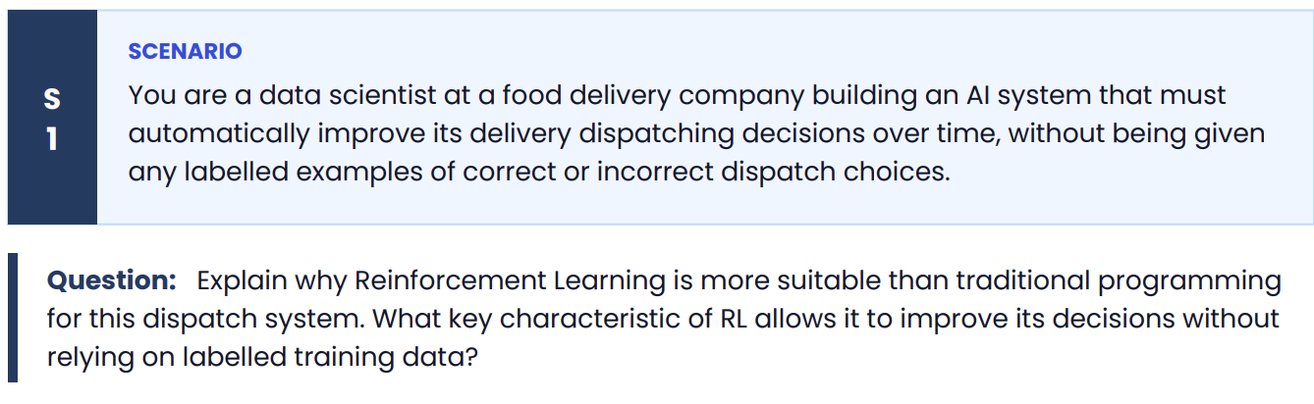
Why Reinforcement Learning (RL) is More Suitable
Reinforcement Learning (RL) is more suitable than traditional programming because the dispatching problem is dynamic and decision-based. Traffic conditions, driver availability, weather, restaurant preparation time, and order volume constantly change, making it difficult to write fixed rules that always produce the best dispatch decision.
Traditional programming relies on manually defined rules, such as:
- Assign the nearest driver.
- Choose the driver with the fewest active orders.
These rules may work in simple situations but cannot adapt to changing real-world conditions.
In contrast, Reinforcement Learning learns the best dispatch strategy through experience. It continuously improves by interacting with the environment and observing the outcomes of its decisions.

Key Characteristic of Reinforcement Learning
The key characteristic of RL is learning through trial and error using a reward signal, rather than relying on labelled training data.
The RL agent follows this process:
- Observe the current state
  - Driver locations
  - Traffic conditions
  - Restaurant preparation times
  - Customer locations
- Take an action
  - Assign a driver to an order.
- Receive a reward
  - Positive reward for fast delivery, low cost, and satisfied customers.
  - Negative reward for delays, cancellations, or inefficient routing.
- Update its policy
  - The agent adjusts its decision-making strategy to maximize future rewards.
Over time, the system learns which dispatch decisions consistently lead to better outcomes.

Why No Labelled Data Is Needed
Unlike supervised learning, RL does not require labelled examples of the "correct" dispatch decision.
Instead of learning from historical labels such as:
- Input → Correct dispatch
the RL agent learns from the consequences of its own actions.
For example:
- Action: Assign Driver A to an order.
- Outcome: Delivery completed in 20 minutes with high customer satisfaction.
- Reward: Positive.
The agent learns that similar decisions are beneficial and is more likely to make them in the future.

Conclusion
Reinforcement Learning is ideal for an automated food delivery dispatch system because it can adapt to changing environments and continuously improve its decisions. Its defining characteristic is that it learns through trial and error using rewards and penalties, allowing it to optimize dispatching decisions without requiring labelled training data.
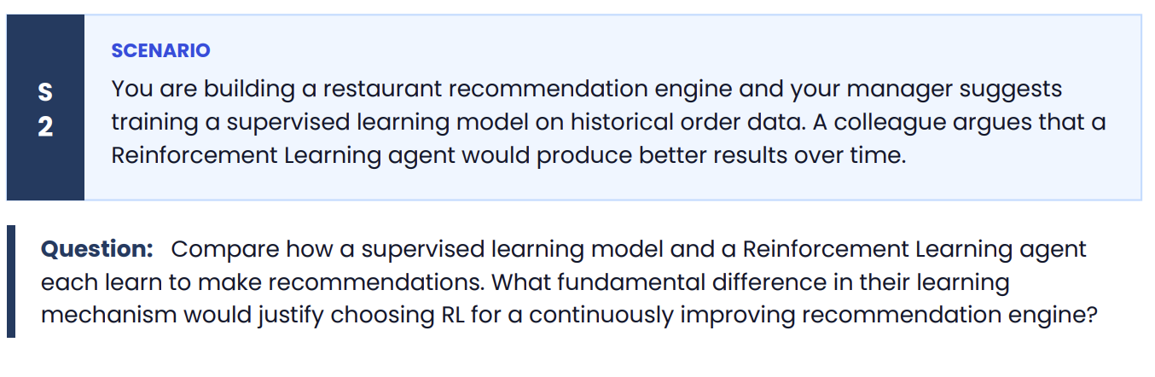
Comparison of Supervised Learning and Reinforcement Learning
Aspect | Supervised Learning | Reinforcement Learning (RL)
Learning Method | Learns from labelled historical data (input → correct output). | Learns by interacting with the environment through trial and error.
Training Data | Requires labelled examples, such as past customer orders and ratings. | Does not require labelled data; instead uses rewards and penalties.
Decision Process | Predicts recommendations based on patterns learned from historical data. | Continuously updates its recommendation strategy based on user feedback.
Adaptability | Performance depends on the training data and requires retraining to adapt to new trends. | Continuously adapts to changing user preferences without complete retraining.

How a Supervised Learning Model Learns
A supervised learning model is trained using historical order data.
For example:
Customer History | Recommended Restaurant (Label)
Ordered pizza frequently | Pizza Palace
Ordered sushi often | Sushi House
The model learns the relationship between customer features and the correct recommendation from labelled examples. Once trained, it predicts restaurants for new customers based on similar patterns.
Limitation:
If customer preferences change (e.g., a customer starts preferring healthy food instead of pizza), the model will not automatically adapt. It usually needs to be retrained with updated data.

How a Reinforcement Learning Agent Learns
A Reinforcement Learning agent learns by interacting with users.
The process is:
- Observe the customer's preferences and current context.
- Recommend a restaurant.
- Receive feedback (reward):
  - Positive reward if the customer clicks, orders, or leaves a good rating.
  - Negative reward if the recommendation is ignored or results in a poor experience.
- Update its recommendation policy to maximize future rewards.
Over time, the RL agent discovers which recommendations produce the highest customer satisfaction and order rates.

Fundamental Difference in Learning Mechanism
The key difference is:
- Supervised Learning learns from labelled historical examples.
- Reinforcement Learning learns from continuous interaction with the environment using rewards and penalties.
RL balances:
- Exploration – trying new restaurant recommendations.
- Exploitation – recommending restaurants that have previously performed well.
This allows the system to continuously improve as new customer behavior is observed.

Why Choose RL for a Continuously Improving Recommendation Engine?
RL is better suited because it can:
- Continuously learn from real-time customer interactions.
- Adapt to changing customer preferences and market trends.
- Optimize long-term objectives such as customer satisfaction, repeat orders, and revenue.
- Improve recommendations without requiring manually labelled training data or frequent retraining.

Conclusion
A supervised learning model learns from labelled historical order data and makes recommendations based on past patterns, but it requires retraining to adapt to new behaviors. In contrast, a Reinforcement Learning agent learns through trial and error using rewards from customer interactions, allowing it to continuously refine its recommendation strategy. This ability to learn from ongoing feedback is the fundamental reason RL is the preferred choice for a continuously improving restaurant recommendation engine.
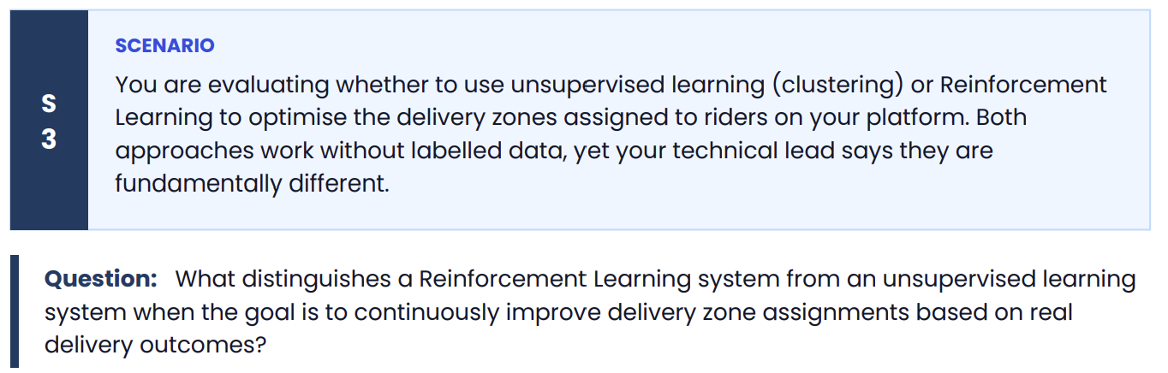
Difference Between Reinforcement Learning and Unsupervised Learning
Although Reinforcement Learning (RL) and Unsupervised Learning both work without labelled data, they learn in fundamentally different ways.
Aspect | Unsupervised Learning (Clustering) | Reinforcement Learning (RL)
Purpose | Finds hidden patterns or groups in data. | Learns the best actions to maximize long-term rewards.
Learning Method | Analyzes similarities in existing data. | Learns through trial and error by interacting with the environment.
Feedback | No feedback or reward signal. | Receives rewards and penalties after each action.
Improvement | Produces fixed clusters unless retrained. | Continuously improves decisions from new experiences.

Unsupervised Learning for Delivery Zones
A clustering algorithm (such as K-Means) can group delivery locations based on features like:
- Customer locations
- Restaurant density
- Order volume
- Geographic distance
For example, it may divide a city into five delivery zones based on location patterns.
However, once the zones are created, the algorithm does not know whether those zones actually improve delivery performance. It has no way to learn from outcomes such as delivery time or customer satisfaction.

Reinforcement Learning for Delivery Zones
An RL agent continuously interacts with the delivery system.
The process is:
- Observe the current state
  - Rider locations
  - Traffic conditions
  - Number of pending orders
  - Current delivery zones
- Take an action
  - Modify delivery zone boundaries or assign riders to different zones.
- Receive a reward
  - Positive reward for faster deliveries, lower costs, and higher customer satisfaction.
  - Negative reward for delays, idle riders, or failed deliveries.
- Update its policy
  - Learn which zone assignments produce the best long-term performance.
Over time, the RL system continuously refines its strategy based on actual delivery outcomes.

Fundamental Difference
The key distinction is that:
- Unsupervised Learning discovers patterns or clusters in data but does not receive feedback on whether its output is good or bad.
- Reinforcement Learning actively makes decisions and learns from the consequences of those decisions using a reward signal.

Conclusion
For continuously improving delivery zone assignments, Reinforcement Learning is more suitable because it uses real delivery outcomes (rewards and penalties) to optimize its decisions over time. In contrast, unsupervised learning only identifies natural groupings in the data and cannot adapt its zone assignments based on delivery performance unless it is retrained.
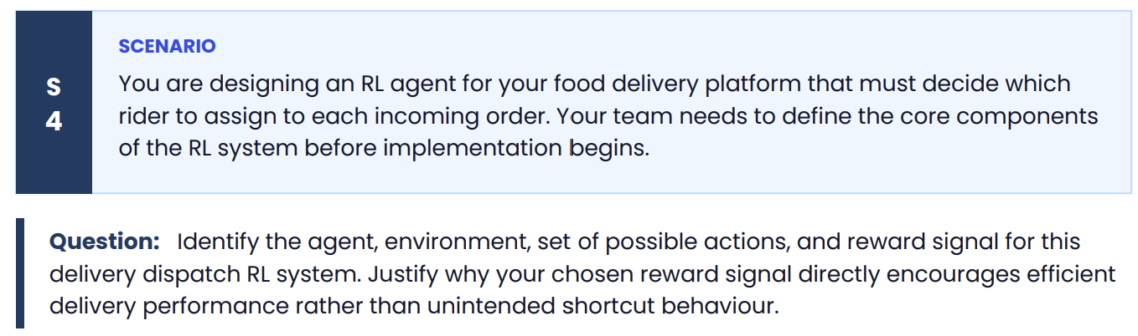
Core Components of the Reinforcement Learning (RL) System
1. Agent
The agent is the delivery dispatch system (AI model) that decides which rider should be assigned to each incoming order.
Role:
- Observe the current delivery situation.
- Select the best rider for each order.
- Learn from the results of its decisions.

2. Environment
The environment is the food delivery platform and its real-world operating conditions.
It includes:
- Available riders
- Customer locations
- Restaurant locations
- Traffic conditions
- Weather
- Order preparation times
- Delivery status
The environment changes continuously and provides feedback after each dispatch decision.

3. Set of Possible Actions
The actions are the possible dispatch decisions the agent can make.
Examples:
- Assign Rider A to the order.
- Assign Rider B to the order.
- Assign Rider C to the order.
- Delay assignment briefly if waiting for a nearby rider is expected to improve efficiency (if allowed by the system).
The agent chooses one action for every incoming order.

4. Reward Signal
The reward should reflect the overall quality of the dispatch decision.
Example reward:
- +10 → Order delivered on time.
- +5 → Short delivery distance or efficient rider utilization.
- +5 → High customer satisfaction (e.g., good rating).
- −10 → Late delivery.
- −15 → Order cancellation due to poor dispatch.
- −5 → Excessive rider idle time or unnecessary travel distance.

Why This Reward Signal Encourages Efficient Delivery
The reward is based on business outcomes rather than a single metric.
It encourages the agent to:
- Deliver orders quickly.
- Reduce delivery delays.
- Minimize unnecessary travel distance.
- Improve rider utilization.
- Increase customer satisfaction.
- Reduce cancellations.
Because rewards combine multiple objectives, the agent learns to optimize overall delivery performance instead of focusing on only one factor.

Avoiding Unintended Shortcut Behaviour
If the reward were based only on delivery time, the agent might exploit the system by:
- Always assigning the nearest rider, even if that rider is already overloaded.
- Ignoring fairness among riders.
- Increasing future delays because some riders become overworked while others remain idle.
Similarly, if the reward were based only on customer ratings, the agent might prioritize easy deliveries and neglect difficult but important orders.
By combining timeliness, efficiency, customer satisfaction, and operational costs into the reward function, the agent is encouraged to make balanced decisions that improve the overall performance of the delivery platform rather than exploiting a single objective.

Summary of RL Components
Component | Example in Food Delivery Dispatch
Agent | AI dispatch system that assigns riders to orders
Environment | Food delivery platform (riders, orders, traffic, restaurants, customers)
Actions | Assign a specific rider (or delay assignment if permitted)
Reward | Positive rewards for on-time deliveries, efficient routing, and customer satisfaction; negative rewards for delays, cancellations, and inefficient dispatch
Conclusion
The RL agent learns by interacting with the delivery environment and receiving rewards based on the outcomes of its dispatch decisions. A well-designed reward signal that balances delivery time, rider utilization, customer satisfaction, and operational efficiency ensures the agent learns behaviors that improve the overall performance of the food delivery platform while discouraging unintended shortcut strategies.
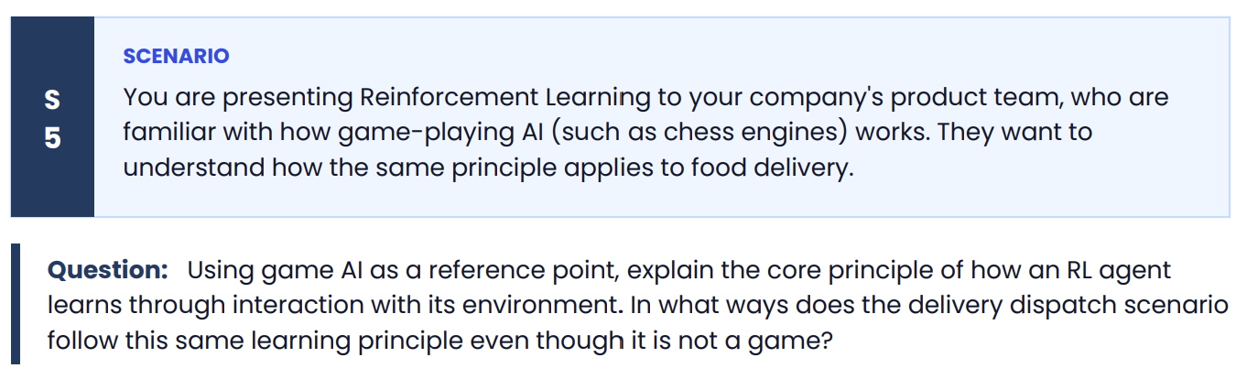
Core Principle of Reinforcement Learning (RL)
A Reinforcement Learning (RL) agent learns by interacting with its environment, taking actions, and receiving rewards or penalties based on the outcome of those actions. Its objective is to learn a policy that maximizes the total long-term reward.
The learning process is:
- Observe the current state.
- Take an action.
- Receive a reward or penalty.
- Update its strategy (policy).
- Repeat this process to improve future decisions.

Game AI Example
Consider a chess-playing AI.
- State: Current arrangement of pieces on the chessboard.
- Action: Choose the next move.
- Reward: Positive reward for winning the game, negative reward for losing, and intermediate rewards for advantageous positions.
- Learning: Over many games, the AI learns which moves increase its chances of winning.
The AI is not programmed with every possible move. Instead, it improves through repeated interaction and feedback.

Applying the Same Principle to Food Delivery
Although food delivery is not a game, the learning process is the same.
State
The RL agent observes:
- Rider locations
- Customer locations
- Restaurant preparation times
- Traffic conditions
- Current order queue
Action
The agent decides:
- Which rider should be assigned to each incoming order.
Reward
After the delivery, it receives feedback such as:
- Positive reward for on-time delivery and satisfied customers.
- Negative reward for delays, cancellations, or inefficient routing.
Learning
By repeating this process over thousands of deliveries, the agent learns which dispatch decisions consistently produce the best outcomes.

Similarities Between Game AI and Delivery Dispatch
Game AI (Chess) | Food Delivery RL
Observe the board state | Observe riders, orders, traffic, and restaurants
Choose the next move | Assign a rider to an order
Win or lose the game | Receive rewards based on delivery performance
Improve strategy through repeated games | Improve dispatch policy through repeated deliveries

Conclusion
Both game-playing AI and a food delivery dispatch system use the same Reinforcement Learning principle:
- Observe the environment.
- Take an action.
- Receive a reward or penalty.
- Update the policy to improve future decisions.
The main difference is the environment: a chess AI learns to maximize its chance of winning games, while a food delivery RL agent learns to maximize operational efficiency, on-time deliveries, and customer satisfaction. Even though delivery dispatch is not a game, it follows the same trial-and-error learning process that enables continuous improvement over time.
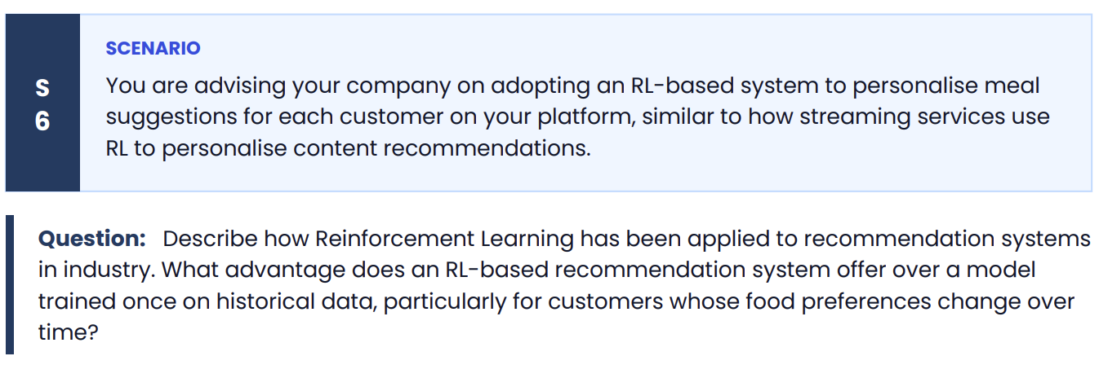
Reinforcement Learning (RL) in Recommendation Systems
Many companies use Reinforcement Learning (RL) to personalize recommendations by learning from users' real-time interactions. Examples include:
- Streaming services (e.g., movies and TV shows) recommend content based on what users watch, skip, or rate.
- E-commerce platforms recommend products based on clicks and purchases.
- Food delivery platforms can recommend restaurants or meals based on browsing behavior, previous orders, ratings, and recent interactions.
Instead of relying only on historical data, the RL system continuously updates its recommendation strategy based on how users respond.

How RL Works in a Food Delivery Recommendation System
The RL agent follows these steps:
- Observe the current state
  - Customer's previous orders
  - Time of day
  - Location
  - Current browsing history
  - Recent ratings and preferences
- Take an action
  - Recommend a meal or restaurant.
- Receive a reward
  - Positive reward if the customer clicks the recommendation, places an order, or gives a high rating.
  - Negative reward if the recommendation is ignored or results in a poor experience.
- Update its policy
  - Learn which recommendations are most successful and improve future suggestions.

Advantage Over a Model Trained Once on Historical Data
A model trained only on historical data learns patterns from the past and typically remains unchanged until it is retrained.
For example:
- A customer frequently ordered pizza last year.
- The supervised model continues recommending pizza because that is what it learned from the historical data.
However, suppose the customer now prefers healthy salads and vegetarian meals. A model trained once may continue recommending pizza until new data is collected and the model is retrained.
An RL-based recommendation system adapts much faster. As it observes that the customer starts ordering salads and ignores pizza recommendations, it receives rewards for successful salad recommendations and penalties for unsuccessful pizza recommendations. It gradually shifts its recommendations to match the customer's new preferences.

Why RL Is Better for Changing Preferences
An RL-based recommendation system offers several advantages:
- Continuously learns from real-time customer interactions.
- Adapts quickly to changing tastes and preferences.
- Balances exploration (trying new meal recommendations) with exploitation (recommending meals known to be liked).
- Improves long-term customer engagement, satisfaction, and repeat orders.

Conclusion
Reinforcement Learning has been widely applied in recommendation systems because it learns directly from user interactions rather than relying solely on historical data. For a food delivery platform, an RL-based recommendation engine continuously updates its recommendations based on customer feedback, making it much more effective for users whose food preferences change over time. This continuous adaptation leads to more relevant meal suggestions, higher customer satisfaction, and increased repeat orders.

